**Detailed Report**

I divided reading tasks into 3 different sections

1. Responsive web applications (Book and Articles on the Internet)
2. Responsive Data Visualizations for the web (Mainly from the book)
3. Responsive Bar Charts (Articles on the Internet)
4. **Responsive web applications**

Started reading about how to make web applications responsive. Referred few articles on the Internet.

* <https://www.w3schools.com/css/css_rwd_intro.asp>

I think this is the best site to get the basic details about responsive web applications. It has detail explanation of tools we can use to make application responsive. After reading I thought Media Queries or Frameworks would be the best way to develop applications.

* <https://www.smashingmagazine.com/2013/06/building-a-responsive-web-application/>

This covers almost same points as mentioned on w3schools website but here Author mentioned few problems with tools and it’s bit more technical.

* To learn more about Media Queries I referred below articles
  + <https://developer.mozilla.org/en-US/docs/Web/CSS/Media_Queries/Using_media_queries>
  + <https://css-tricks.com/snippets/css/media-queries-for-standard-devices/>
  + <https://www.html5rocks.com/en/mobile/responsivedesign/>
* I found writing Media Queries is bit difficult. So I developed sample web application using Bootstrap framework mentioned on w3schools website. Frameworks are built on the top of Media Queries and they are easy to use. Also I found special javascript framework react-bootstrap to develop responsive web application using React JS.
  + <https://www.packtpub.com/books/content/web-development-react-and-bootstrap>

At the end I think development can be done using any framework and javascript library but layout is very important. We need to decide layout of an application on different devices first and then accordingly development should be done.

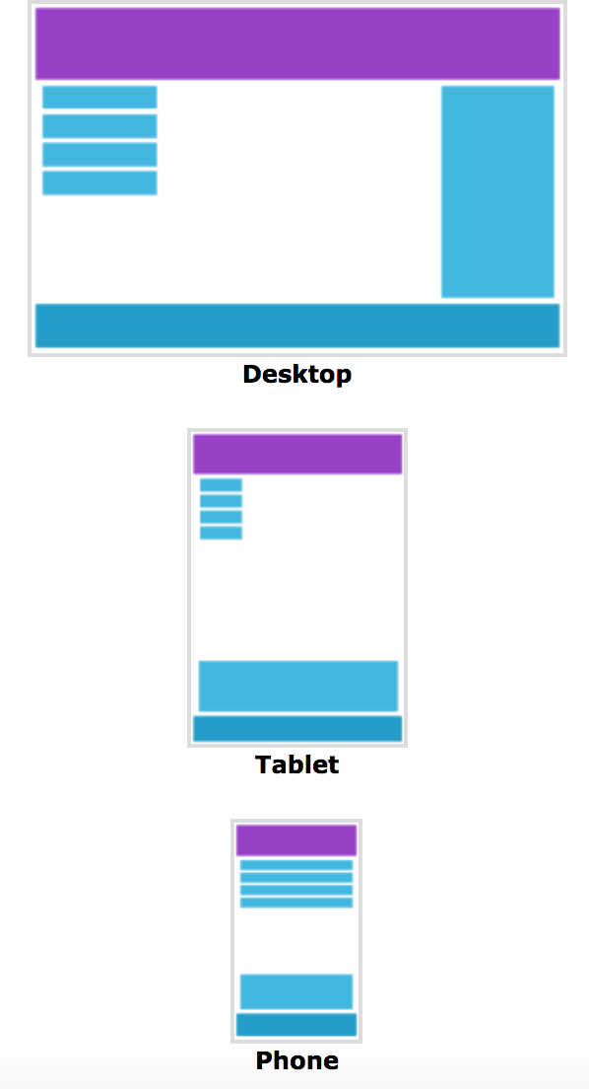 **Image 1** As shown in image 1 if application is viewed on Desktop, as screen size is big we can show right hand section. But once we change the device right hand section should appear at the bottom.

**Image 2**

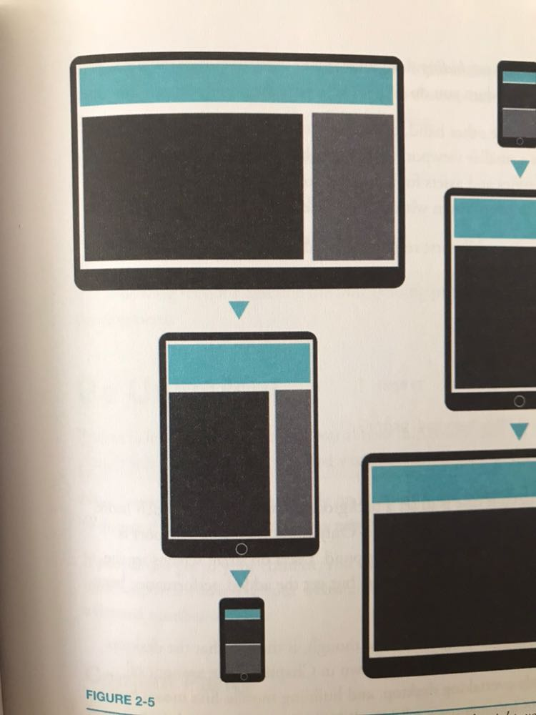

1. **Creating Responsive Data Visualizations**

Part 1 of the book covers details about creating responsive web application. I am currently reading Part 2 that is all about creating responsive data visualization using D3 and CSS. Chapters mainly concentrates on

* Window Resize (resizing all the time) – Major drawback is it becomes expensive if you are redrawing every time page fires a resize event.
* To avoid this issue they explained one more technique find breakpoints. Handle drawing at these breakpoints (drawing modes concept)
* Author talked about one more technique Grouping

I am still reading second part but I think Author explained techniques to make any visualization responsive but till now I didn’t find any useful information regarding points to consider while displaying visualization on small screens like ideas to collate and display information properly on small screens. So that user will not miss any important information and how it can become likeable experience for user.

1. **Responsive Bar Charts**

As of now I decided to concentrate on only one visualization Bar Chart to come up with few ideas on how can we make it effective on mobile screens. I am able to gather few ideas like

* Size and scale SVG elements based on their containers
* Reset scales when the window resizes. (To make labels more readable we can rotate them by 45deg)
* Resize all the things
* Use aspect ratio instead of fixed height

While I was working on this I came across few interesting java libraries for responsive charts. I liked few ideas they have used like bar overlapping, label placement as shown in below images.

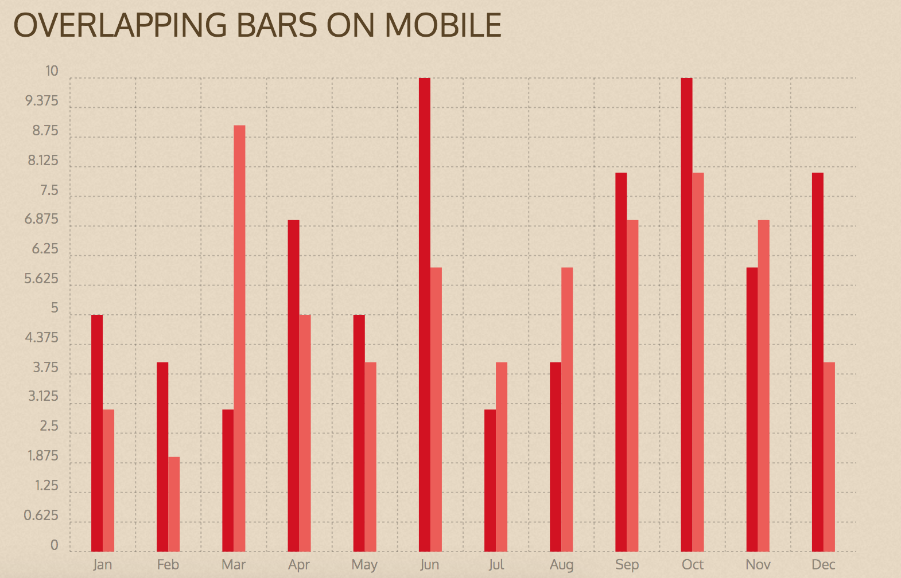

**Image 3**

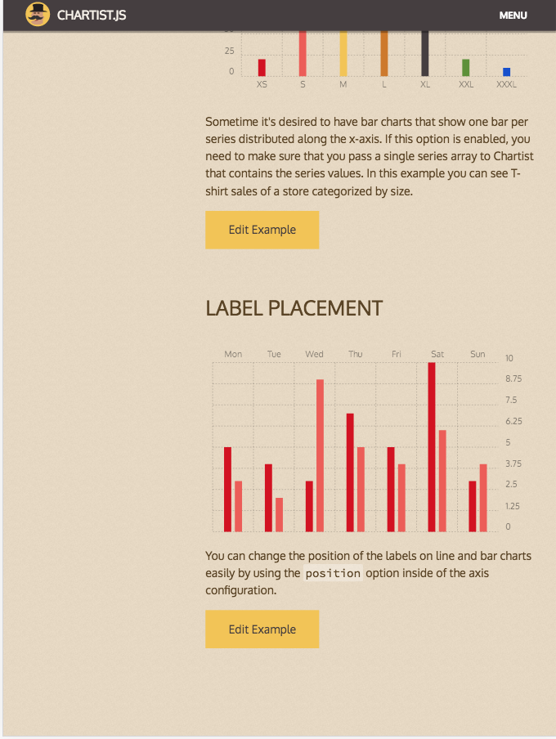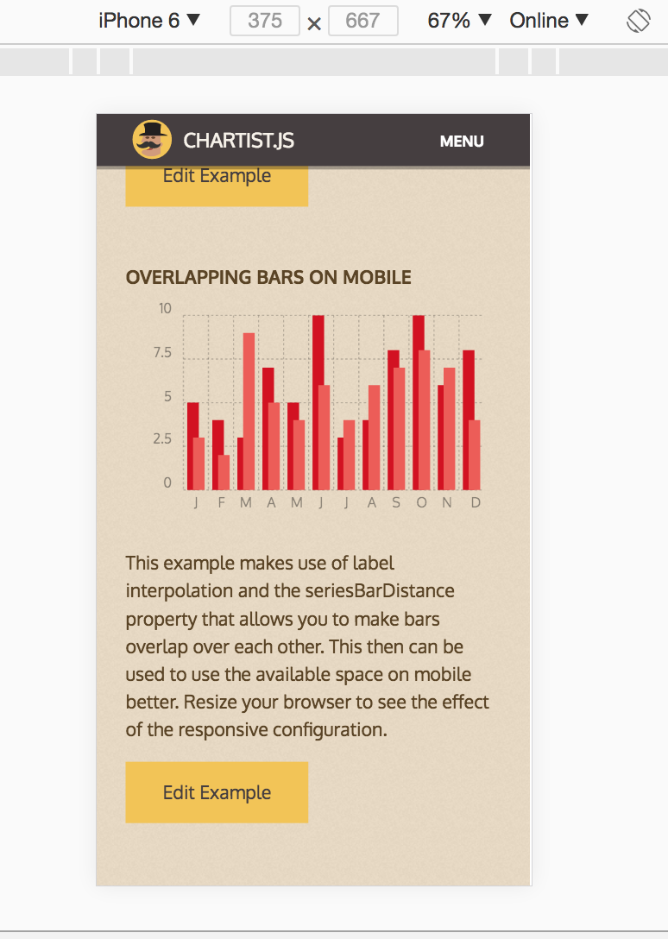

**Image 4 Image 5**

**References**

* <http://eyeseast.github.io/visible-data/2013/08/28/responsive-charts-with-d3/>
* <https://thenextweb.com/dd/2015/06/12/20-best-javascript-chart-libraries/>
* <http://gionkunz.github.io/chartist-js/index.html>
* <https://medium.com/@caspg/responsive-chart-with-react-and-d3v4-afd717e57583>
* <https://blog.webkid.io/responsive-chart-usability-d3/>
* <https://bl.ocks.org/jfsiii/65bb6ffd9ad25f8d3cac83f6e77cbf65>

**Apart from reading I have started working on a sample application to develop responsive bar chart. I am trying to develop it using ideas I mentioned above. I will upload code on github soon.**

**Points to discuss in next meeting**

* Use of available javascript libraries
* Approach – What’s next?
* How to bridge gap between different sizes? How to design applications for better results?
* What are the main problems with present visualizations on mobiles?